1. **Cài đặt Jenkins**

* **SSH vào máy Ubuntu**

*# apt update*

*# apt install openjdk-11-jdk -y*

*# apt install maven -y*

*# curl -fsSL https://pkg.jenkins.io/debian-stable/jenkins.io-2023.key | sudo tee /usr/share/keyrings/jenkins-keyring.asc > /dev/null*

*# echo deb [signed-by=/usr/share/keyrings/jenkins-keyring.asc] https://pkg.jenkins.io/debian-stable binary/ | sudo tee /etc/apt/sources.list.d/jenkins.list > /dev/null*

*# apt-get update*

*# apt-get install jenkins -y*

* **Truy cập Jenkins qua trình duyệt (Browser)**

<http://Jenkins_IP:8080>

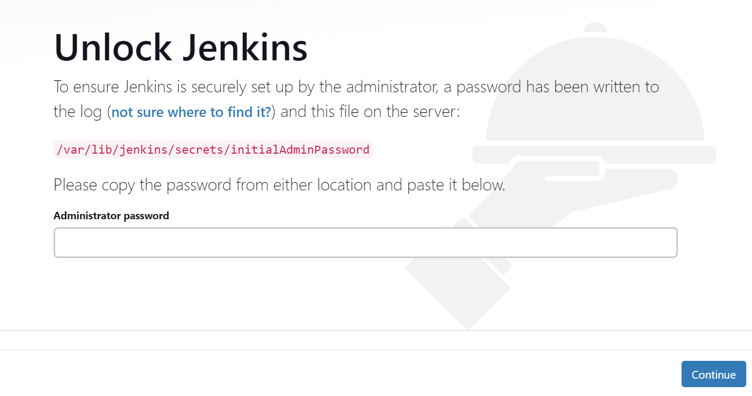

* **Mở file /var/lib/jenkins/secrets/initialAdminPassword**

*# cat /var/lib/jenkins/secrets/initialAdminPassword*

* **Paste chuỗi mật khẩu vào phần Administrator password trên trình duyệt**

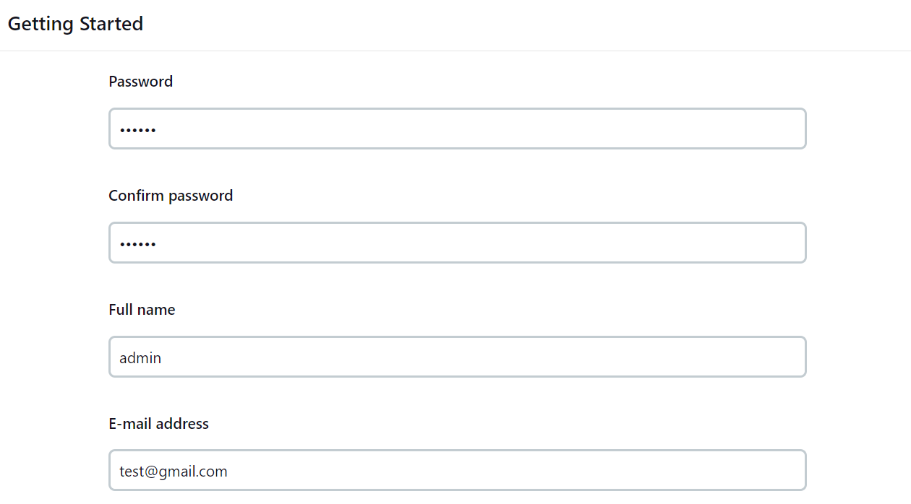

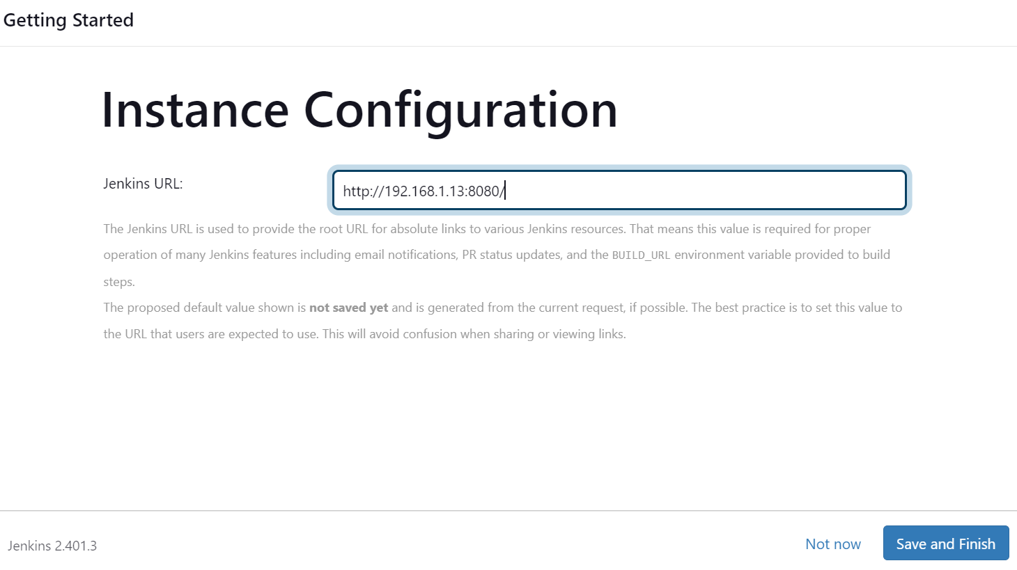

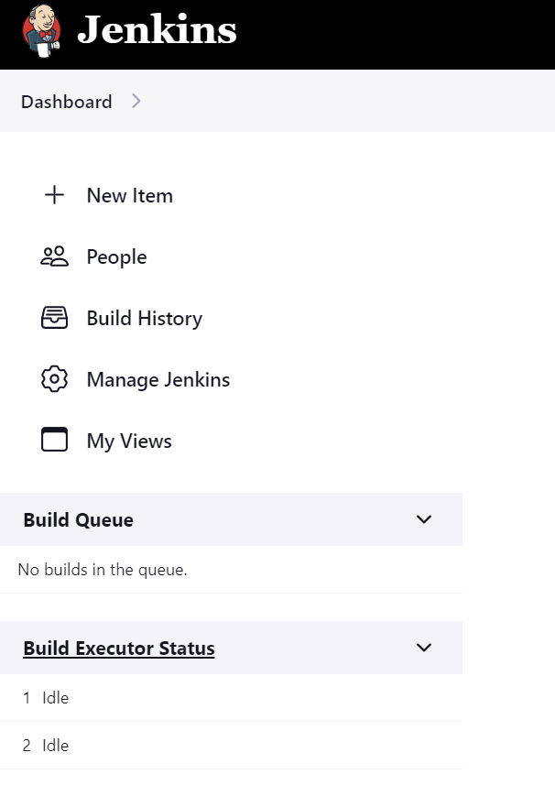

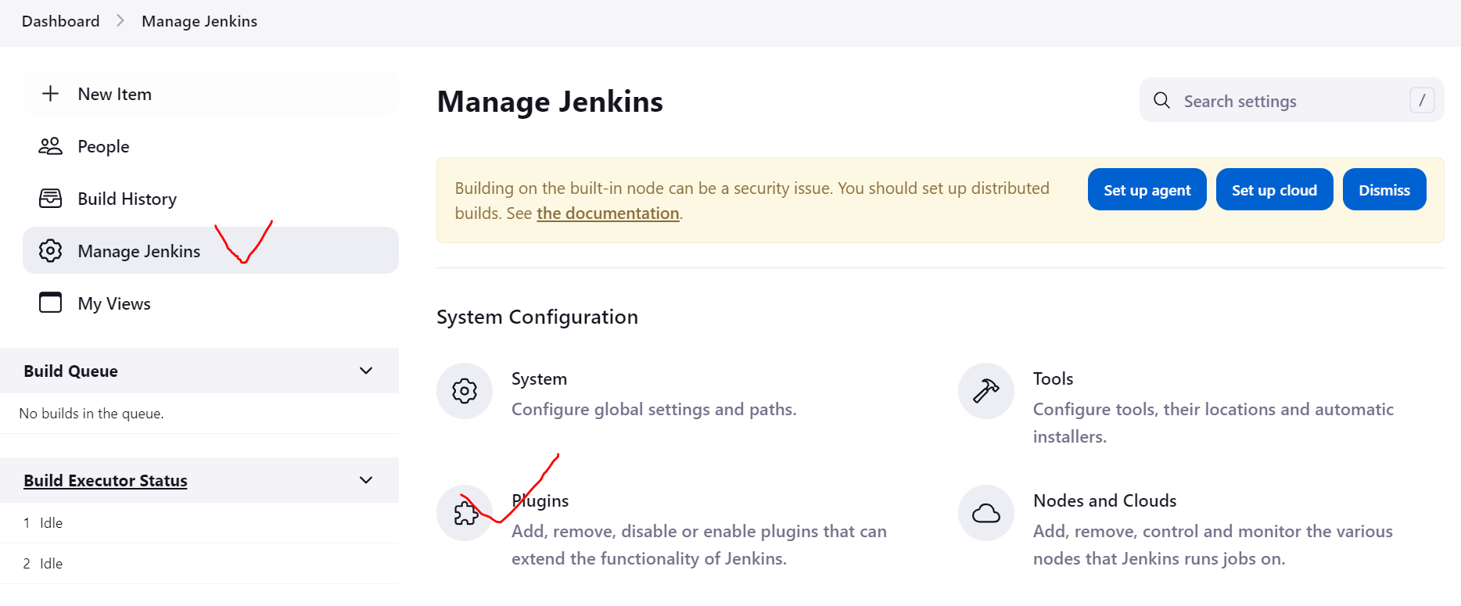

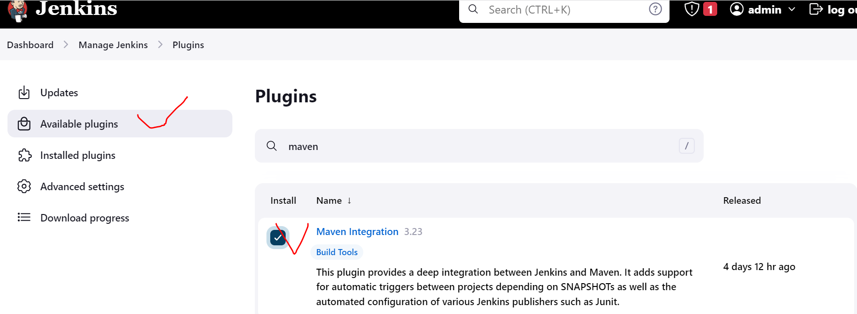

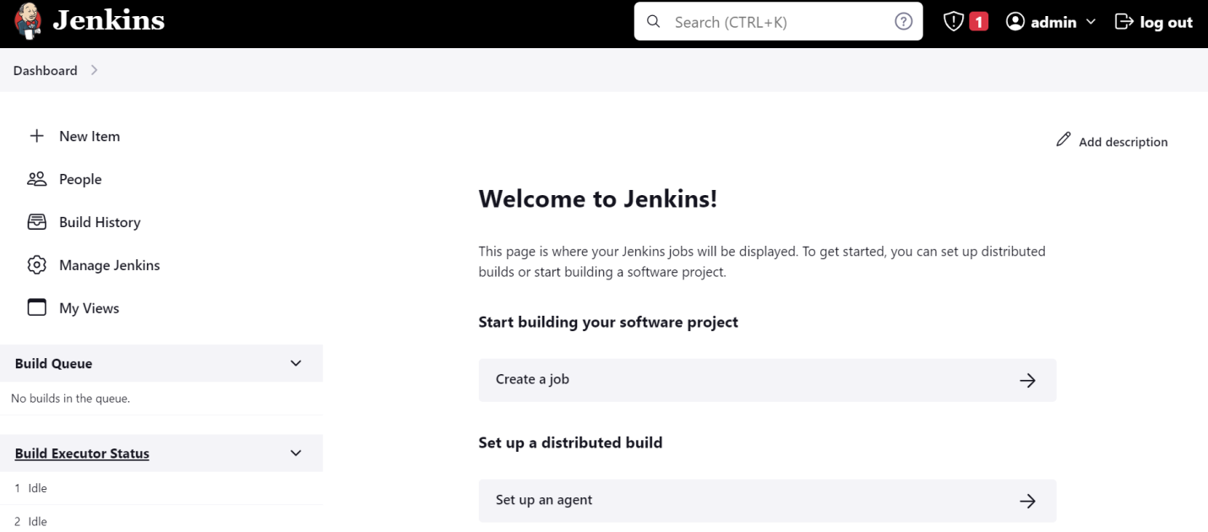

**Integrate Jenkins with GitHub**

1. **Install NGRok on Jenkins server**

Go to link: <https://ngrok.com/download>

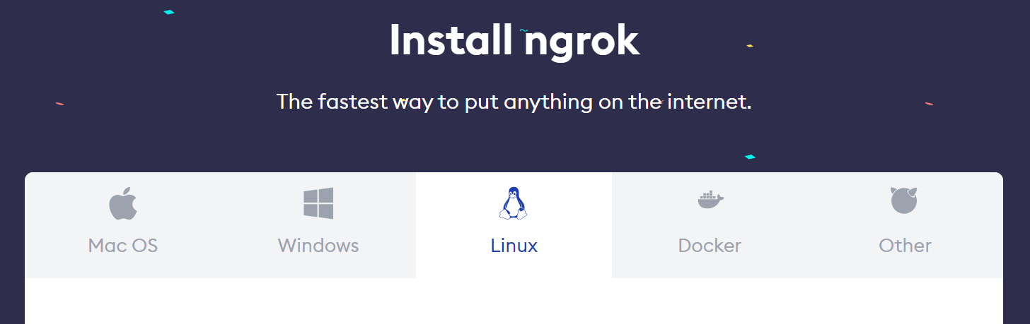

Copy command for Linux:

|  |
| --- |
| *# curl -s https://ngrok-agent.s3.amazonaws.com/ngrok.asc | sudo tee /etc/apt/trusted.gpg.d/ngrok.asc >/dev/null && echo "deb https://ngrok-agent.s3.amazonaws.com buster main" | sudo tee /etc/apt/sources.list.d/ngrok.list && sudo apt update && sudo apt install ngrok* |

Run this command on Jenkins server

ngrok http Jenkins_IP:8080

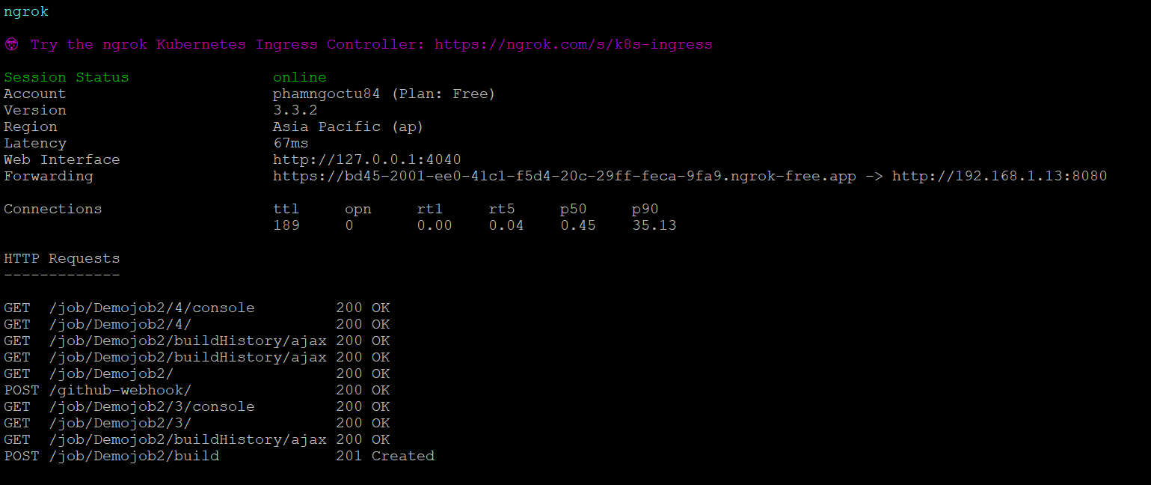

Copy the link on the Forwarding line and then paste to Browser:

<https://bd45-2001-ee0-41c1-f5d4-20c-29ff-feca-9fa9.ngrok-free.app>

Create free account and authozire on ngrok.com

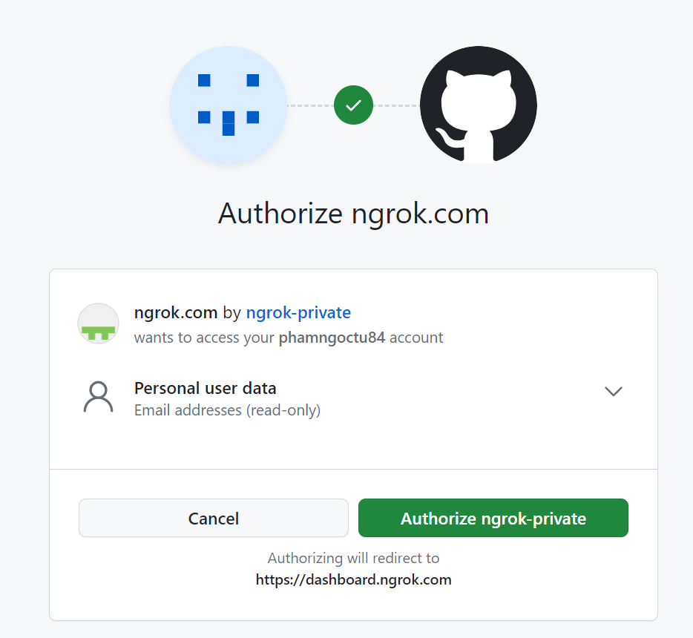

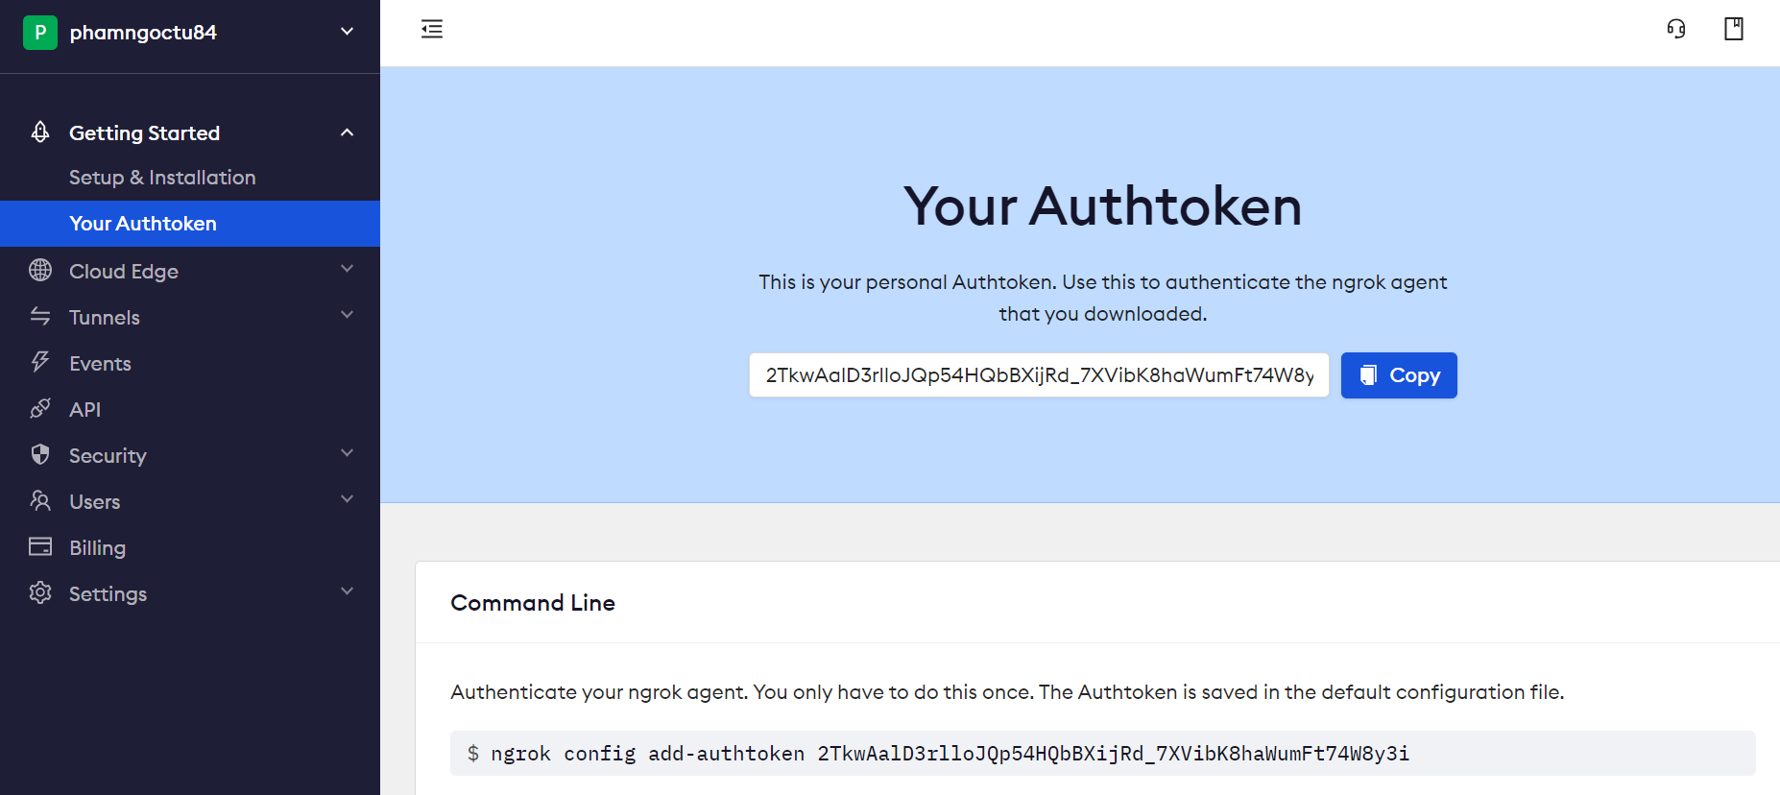

Copy and paste the command authen and run it on Jenkins server

*# ngrok config add-authtoken 2TkwAalD3rlloJQp54HQbBXijRd_7XVibK8haWumFt74W8y3i*

1. **Configure the Webhook on GitHub repository**

Pate the Jenkins’s webhook URL:

<https://bd45-2001-ee0-41c1-f5d4-20c-29ff-feca-9fa9.ngrok-free.app/github-webhook/>

to **PayloadURL** area

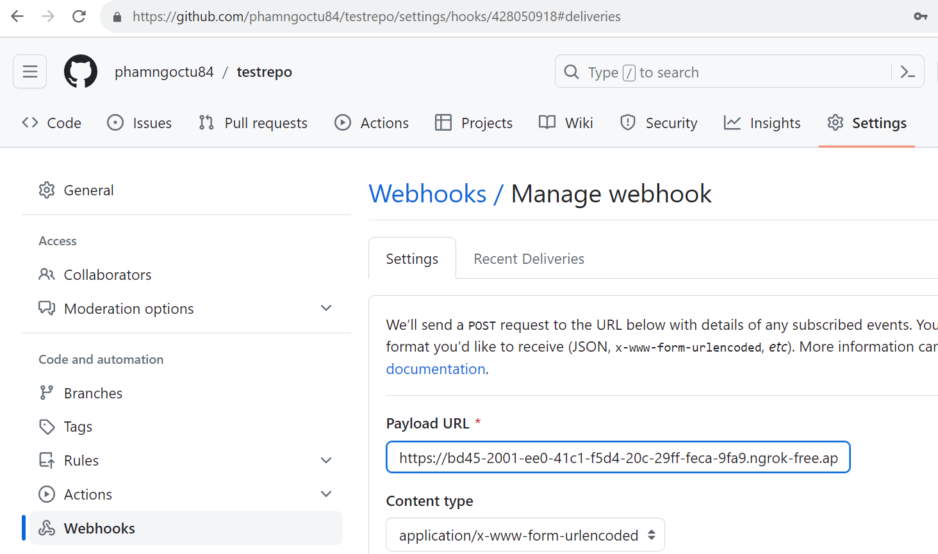

**The result**

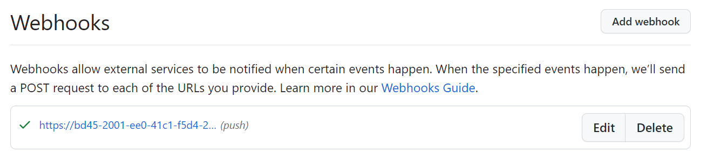

1. **Enable Webhook on Jenkins**

Create new Jenkins Job

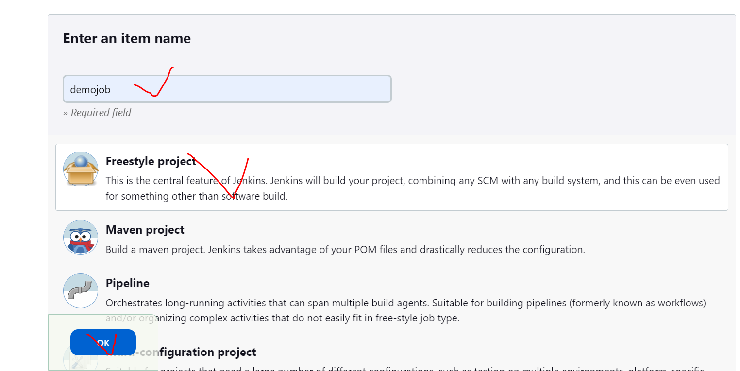

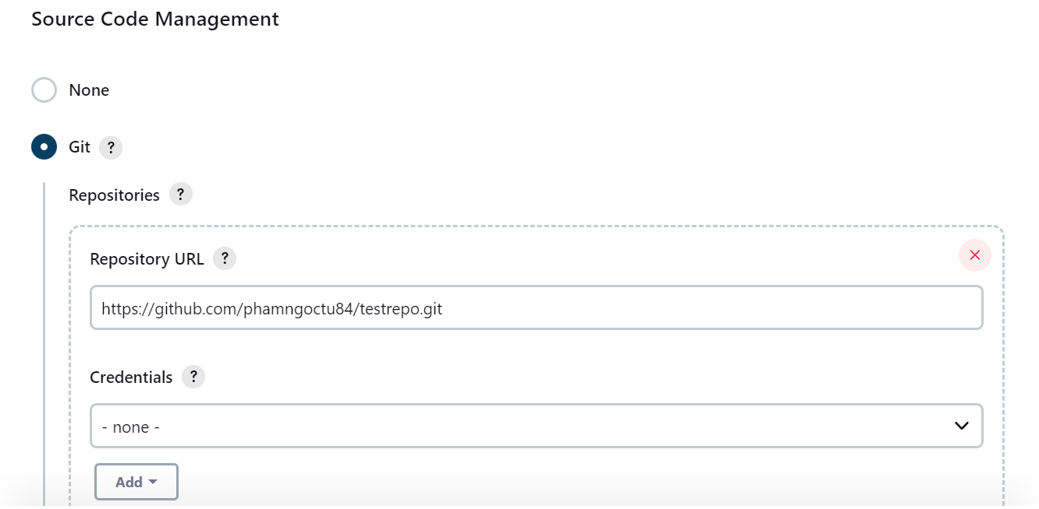

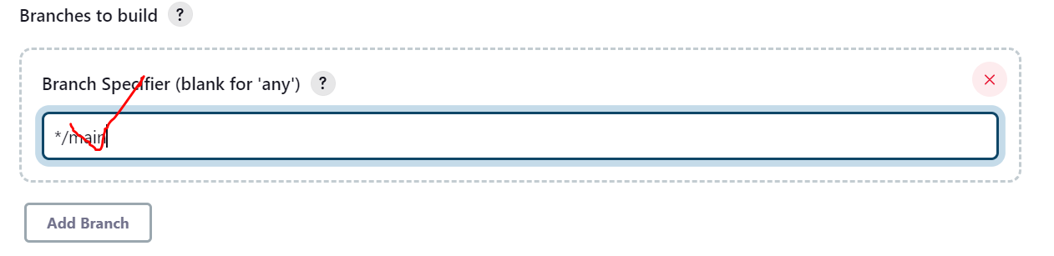

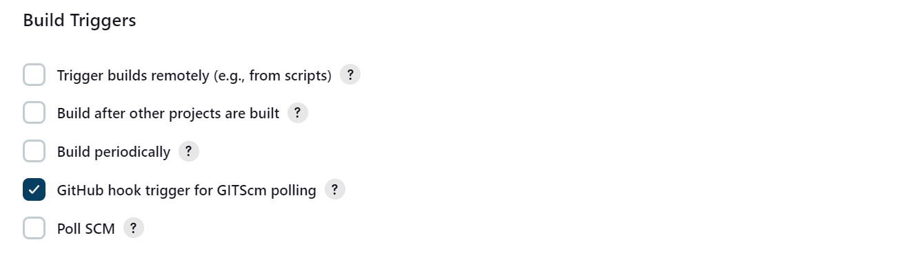

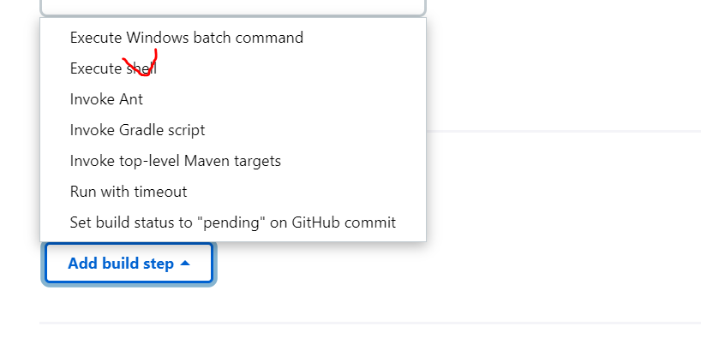

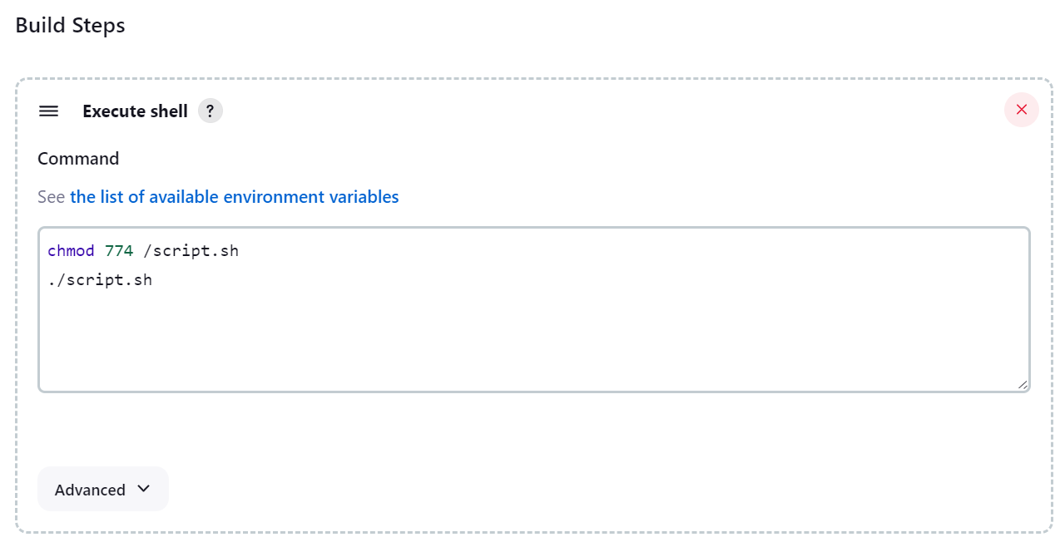

Select **Save** button

1. **Commit change to GitHub repository**

Mở **Git Bash**

*# cd testrepo/*

*# git status*

*# git switch main*

*# vi script.sh*

*# git add .*

*# git commit -m "updated"*

*# git push*

1. Kiểm tra Jenkins Job tự động thực hiện

Trên trình duyệt

1. Jenkins Job with Maven

# vi /etc/profile

Paste cấu hình biến PATH vào cuối file

|  |
| --- |
| *export JAVA_HOME=/usr/lib/jvm/java-1.11.0-openjdk-amd64/*  *export PATH=$JAVA_HOME/bin:$PATH*  *export MAVEN_HOME=/user/share/maven* |

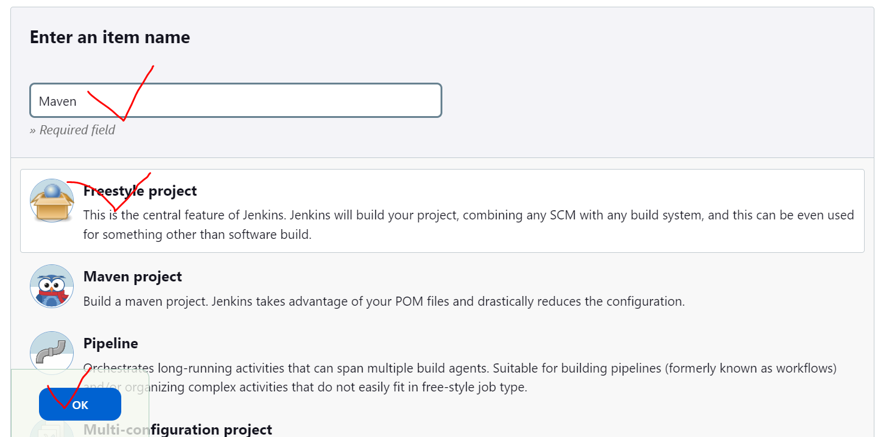

Copy repo URL: https://github.com/shazforiot/HelloWorld-Springboot-App.git

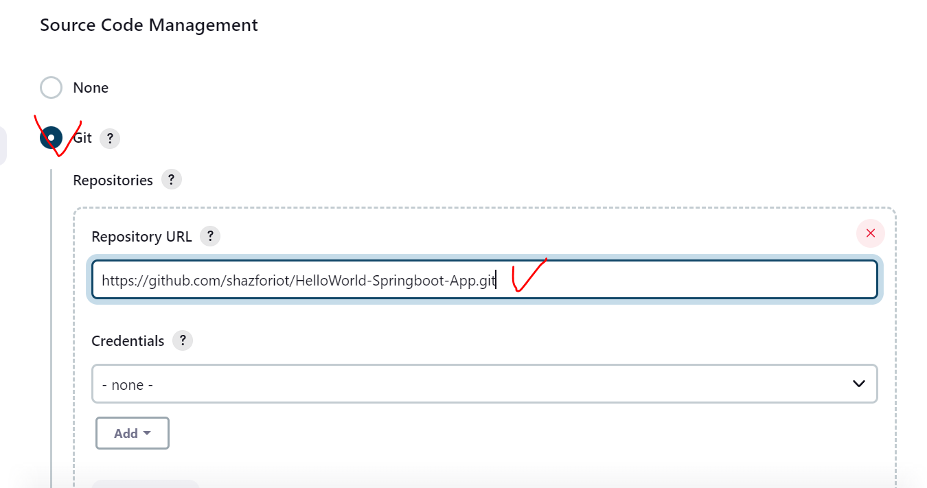

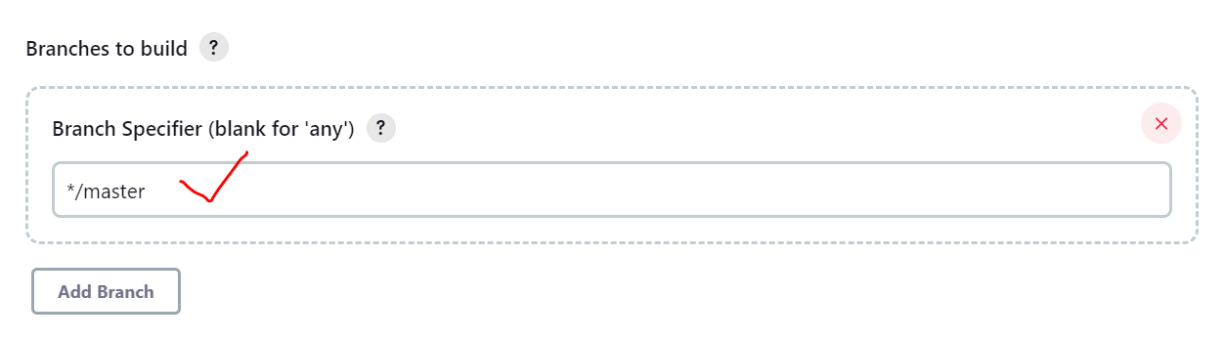

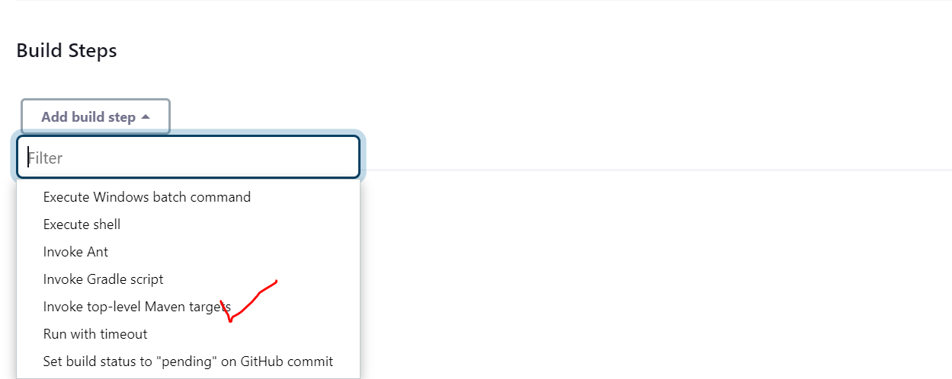

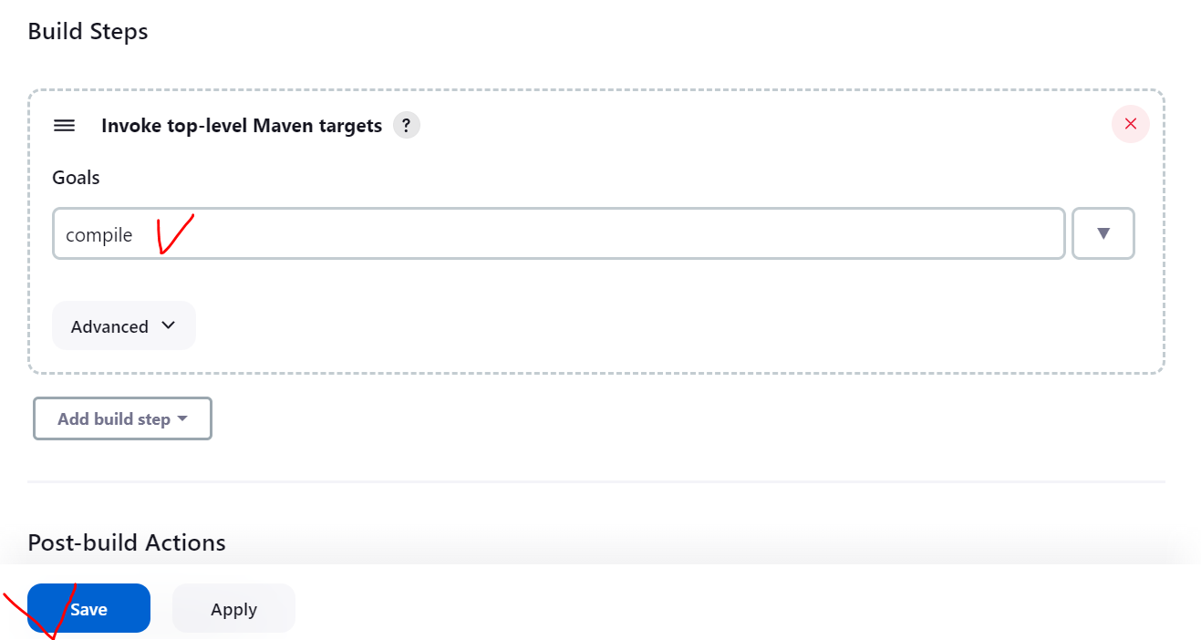

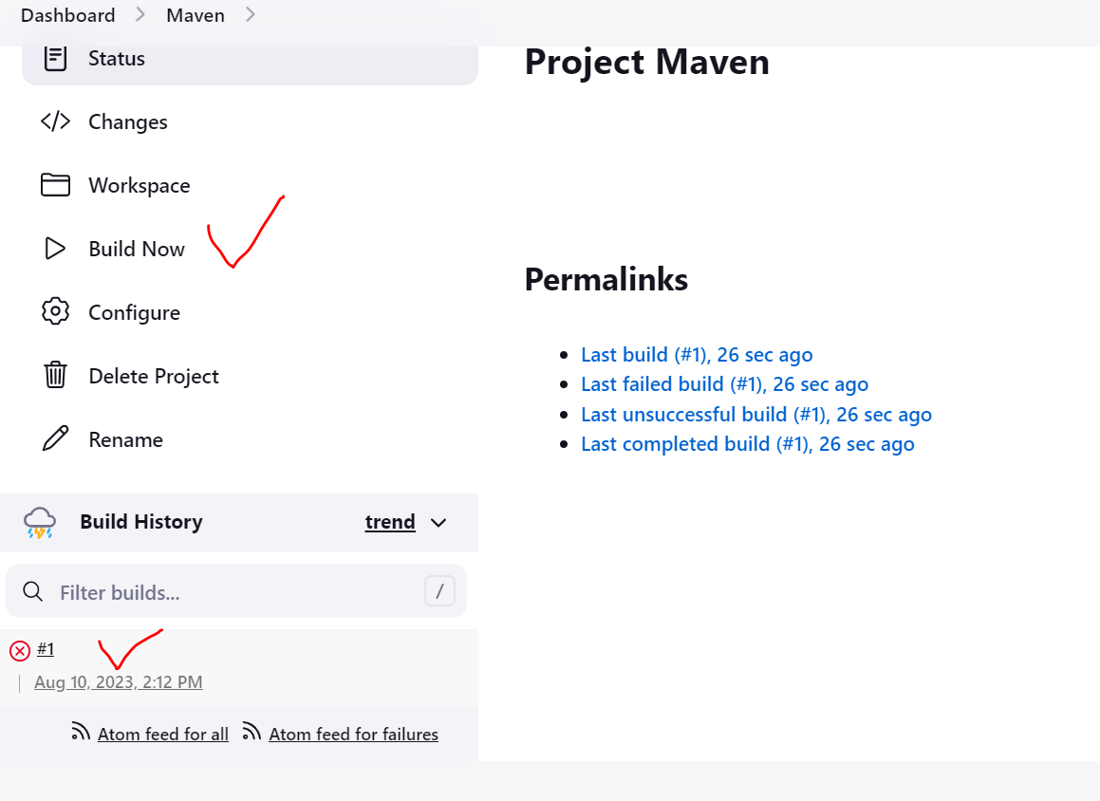

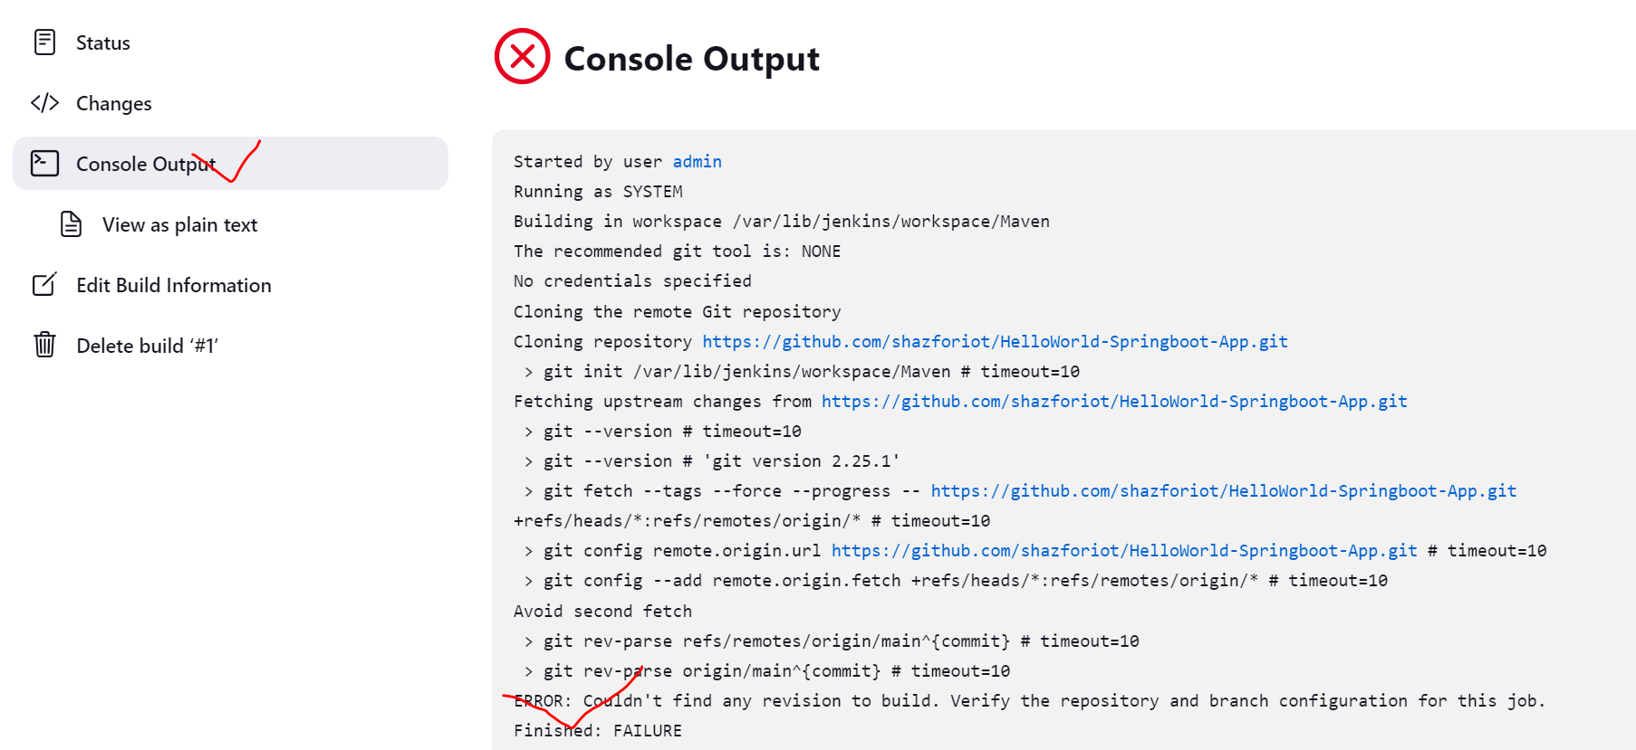

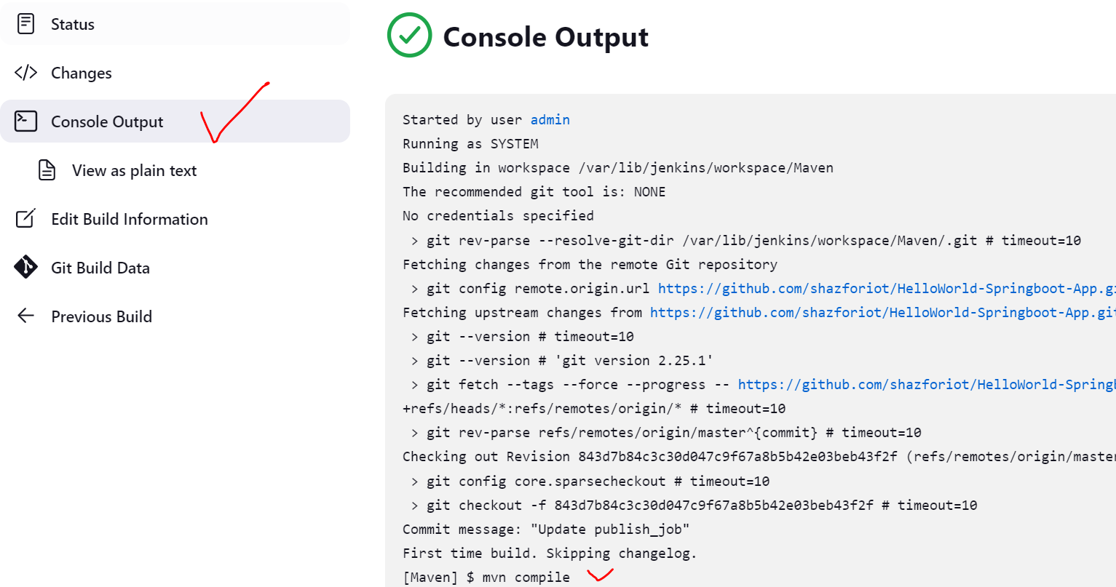

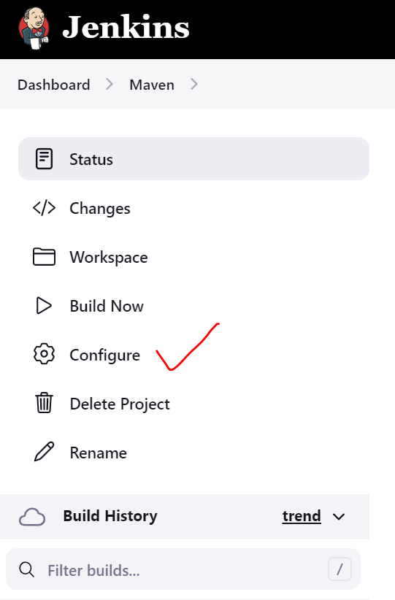

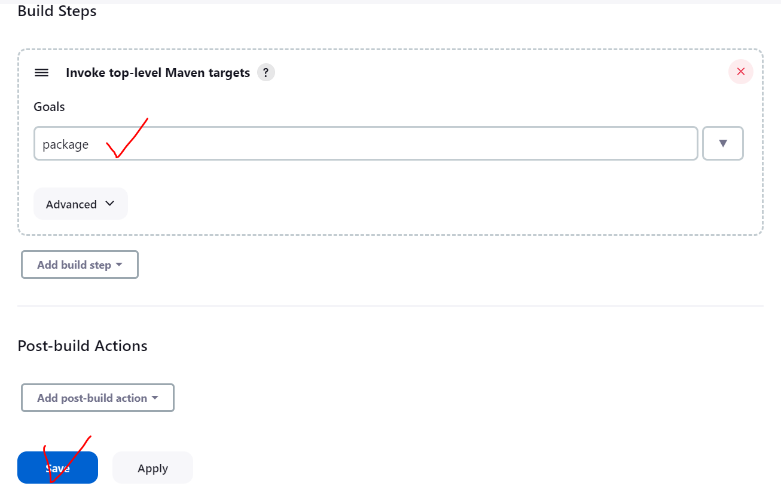

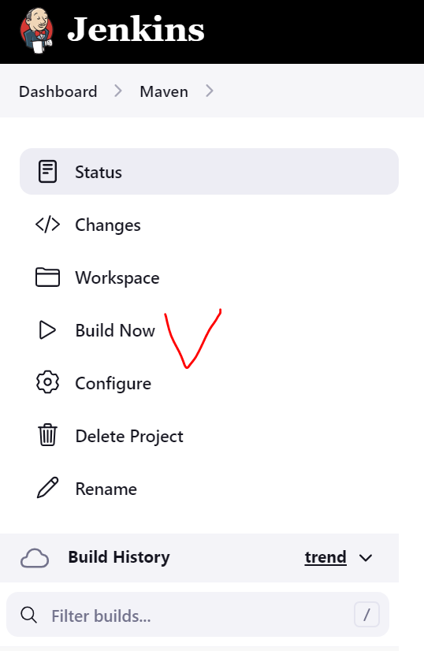

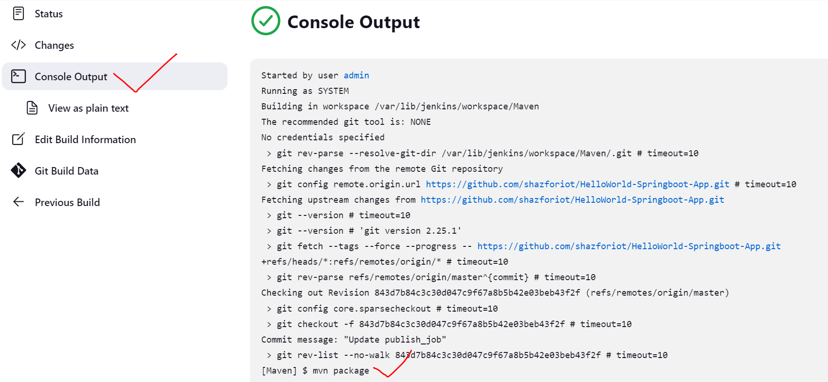

Kiểm tra gói được đóng gói

# cd /var/lib/jenkins/workspace/Maven/target

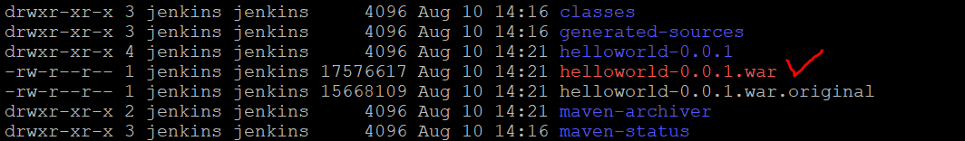

1. Phân quyền theo RBAC

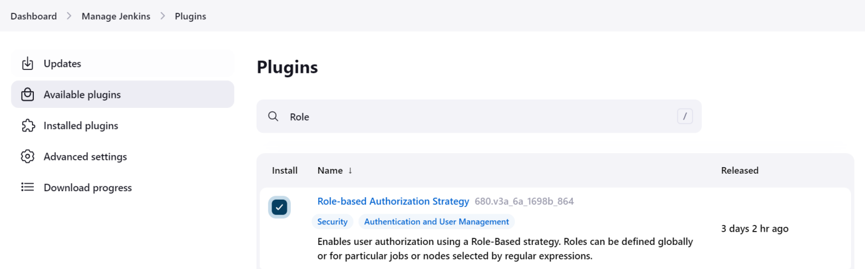

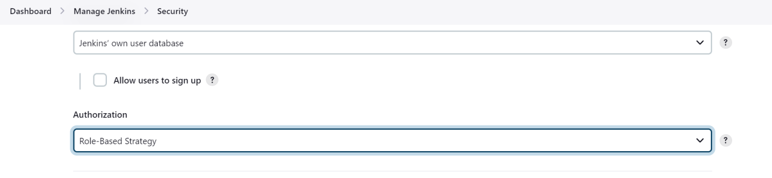

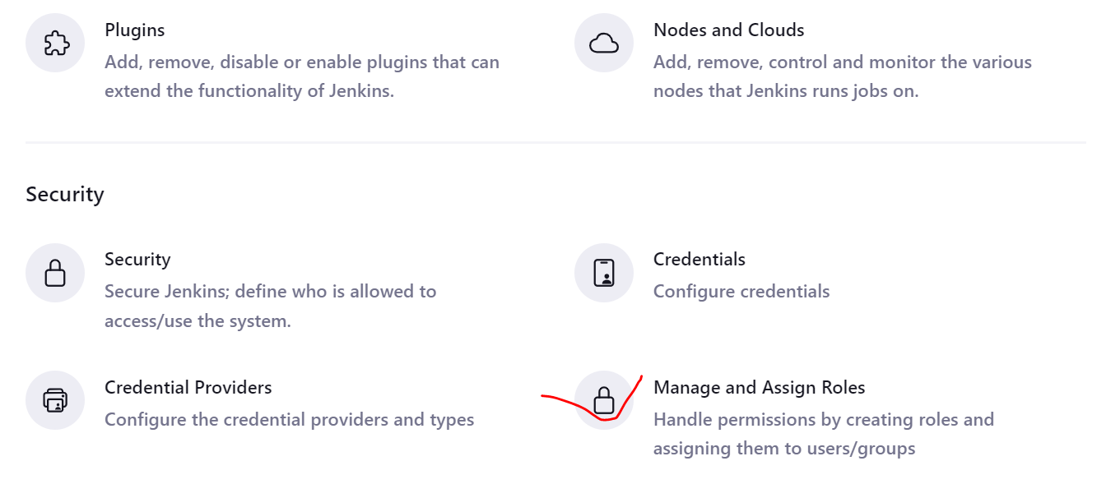

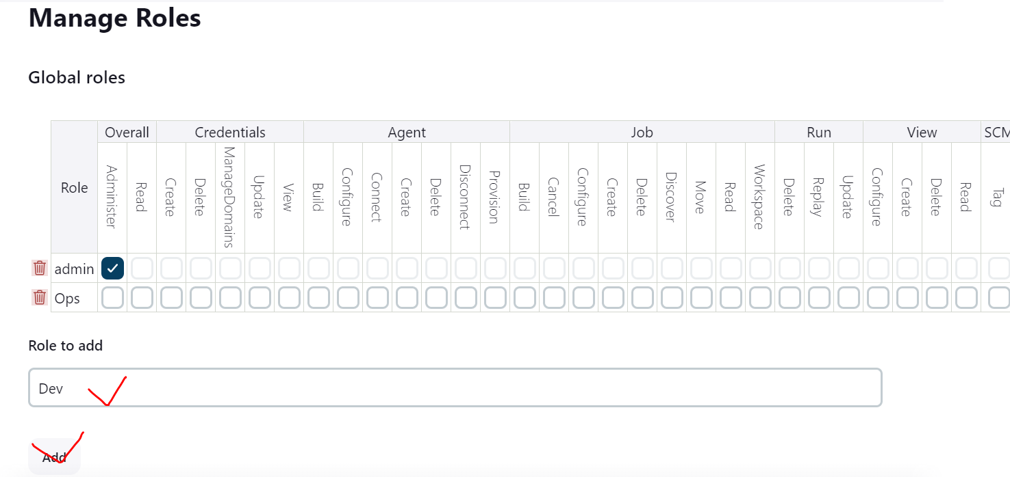

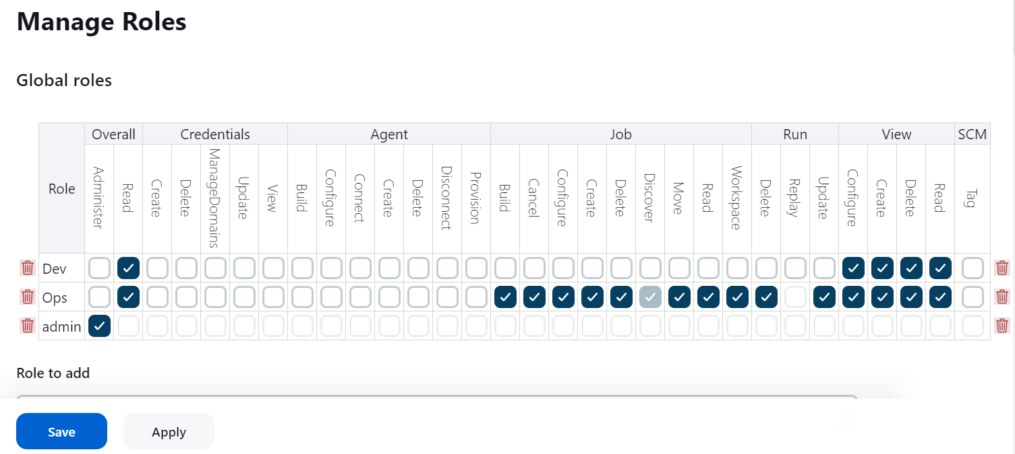

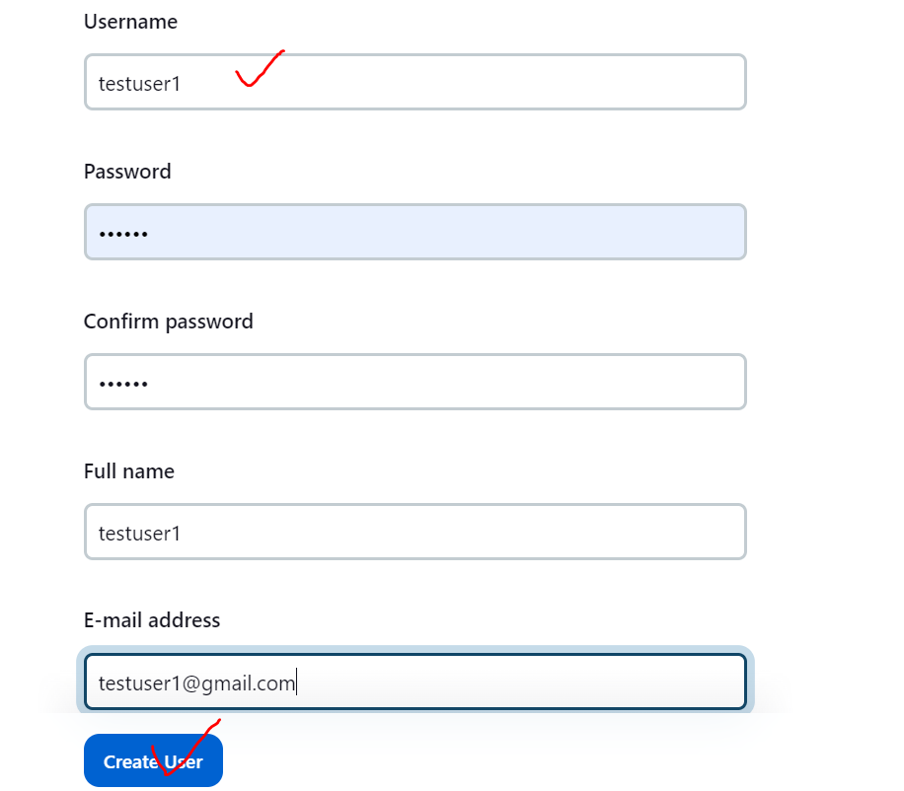

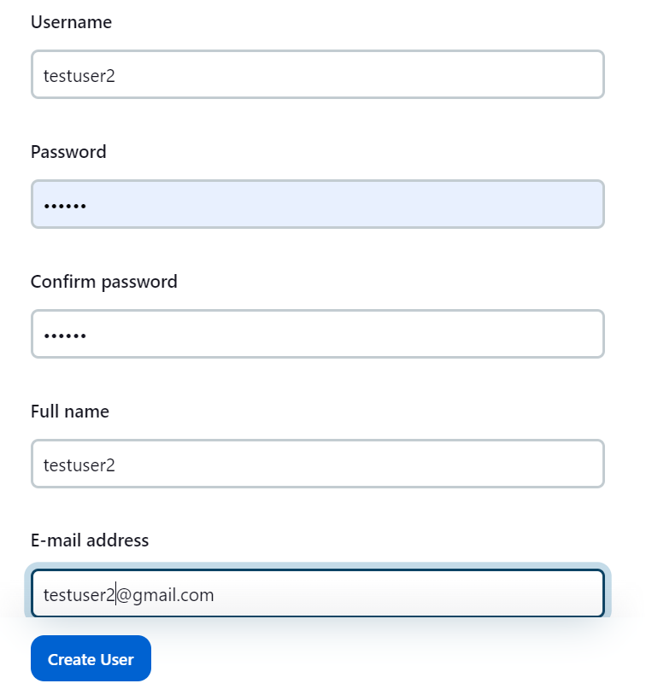

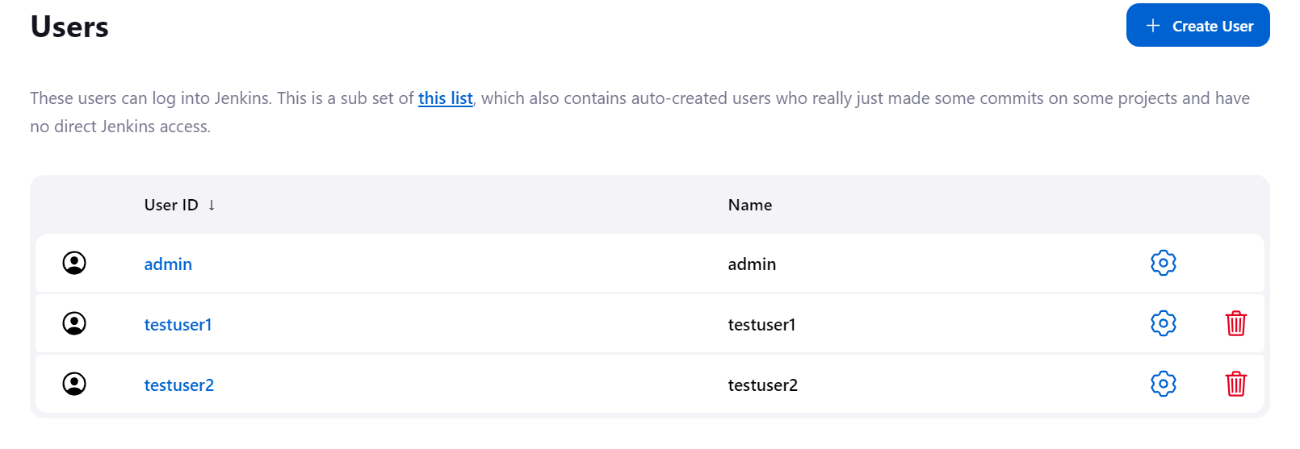

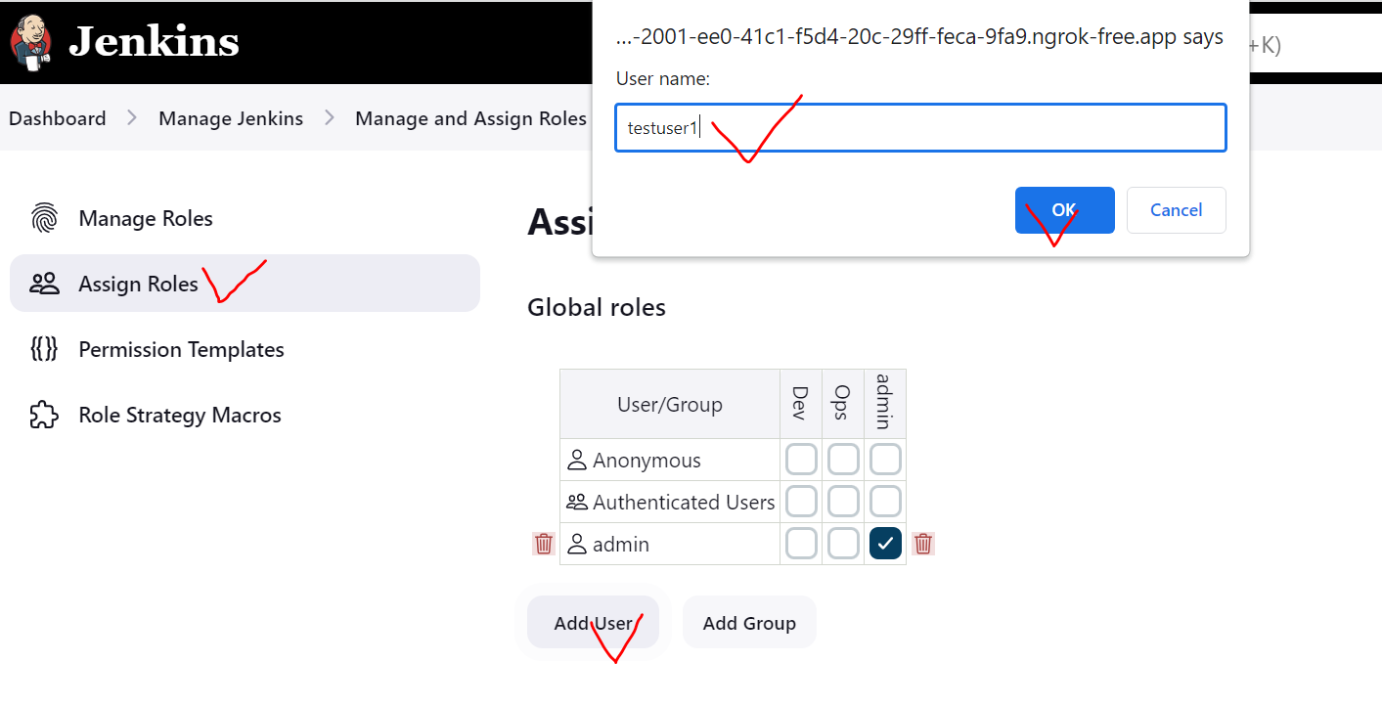

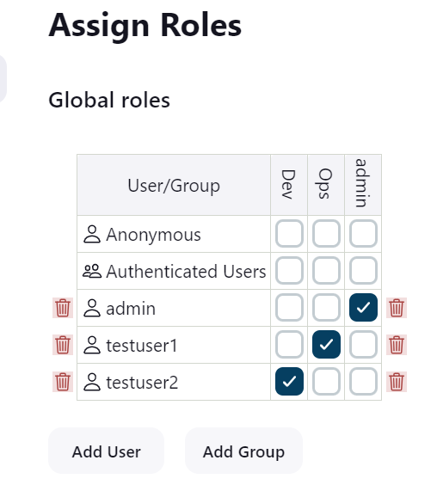

1. Jenkins Pipeline

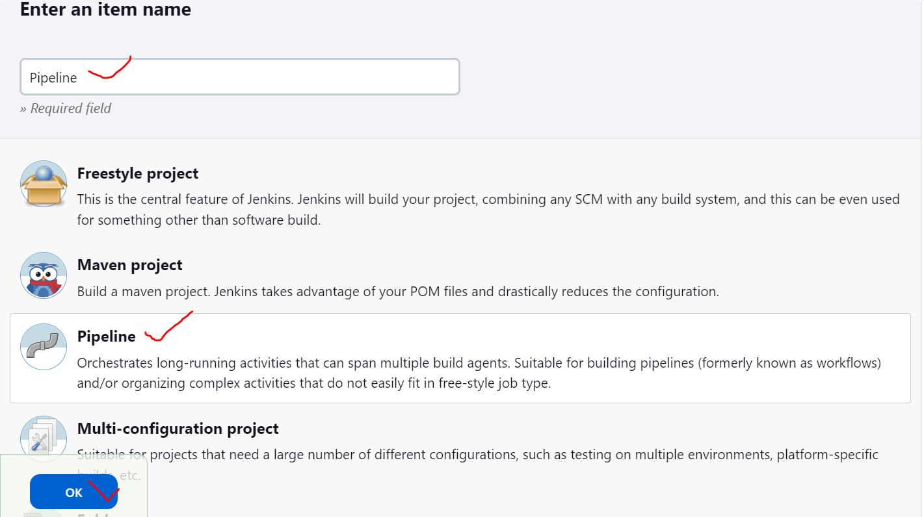

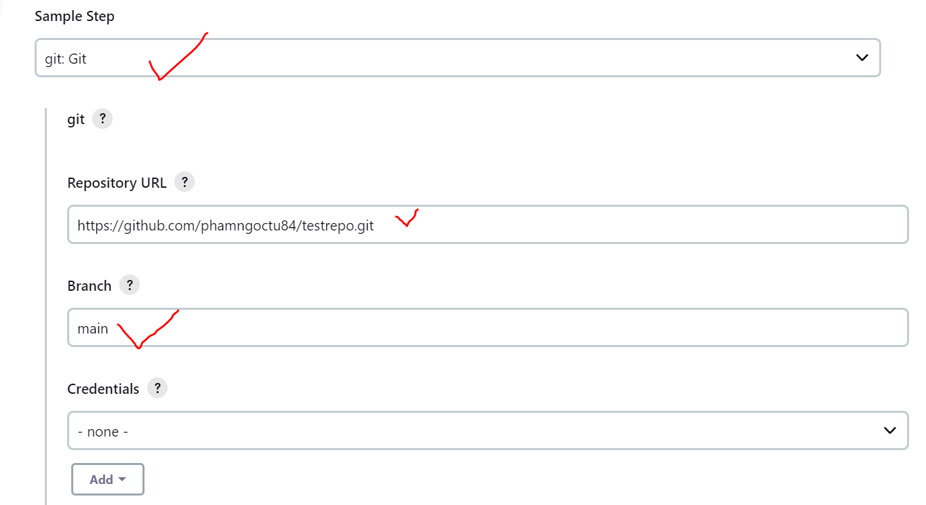

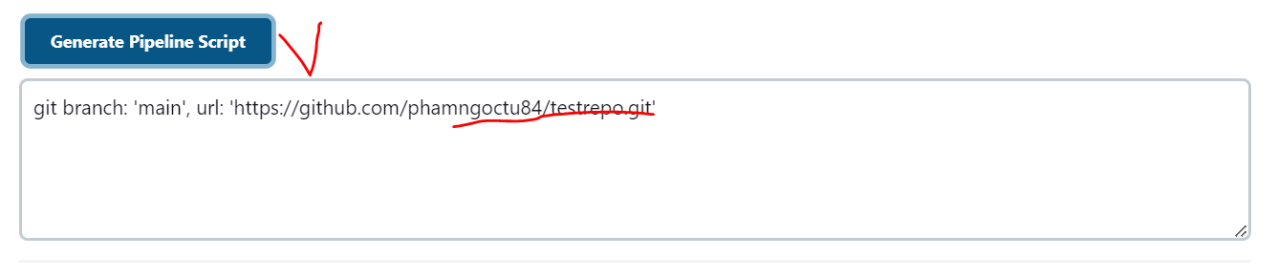

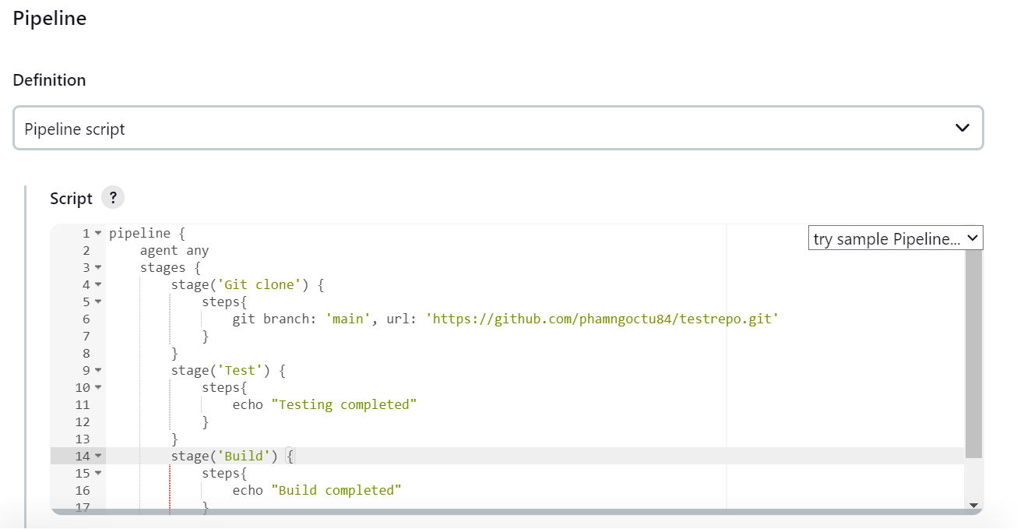

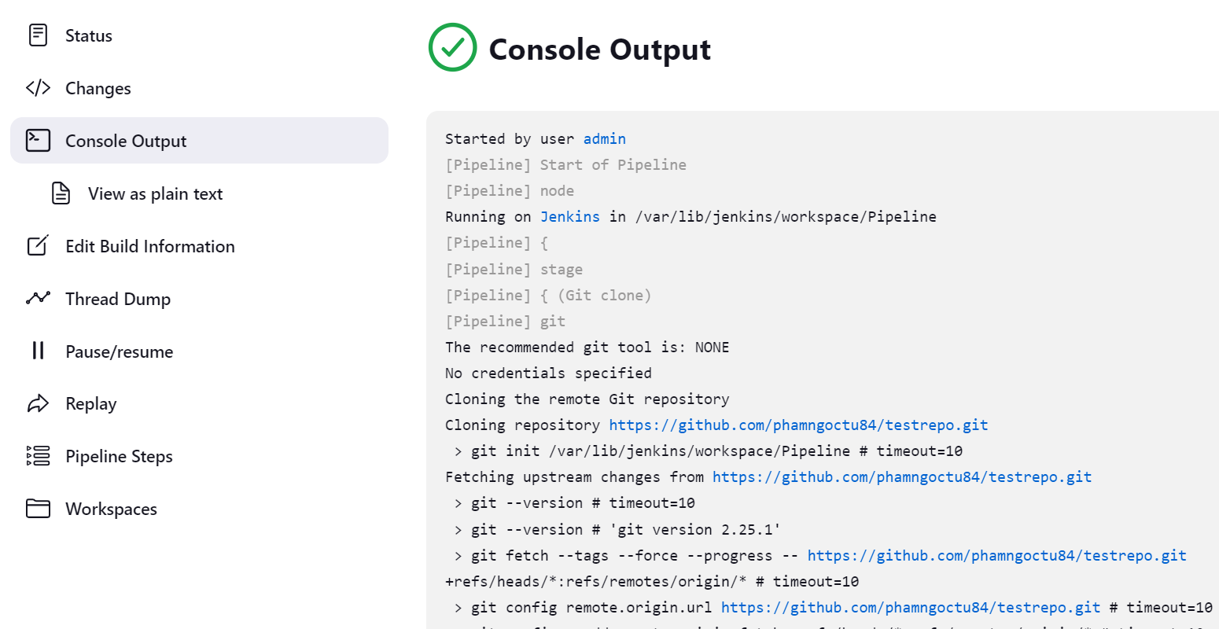

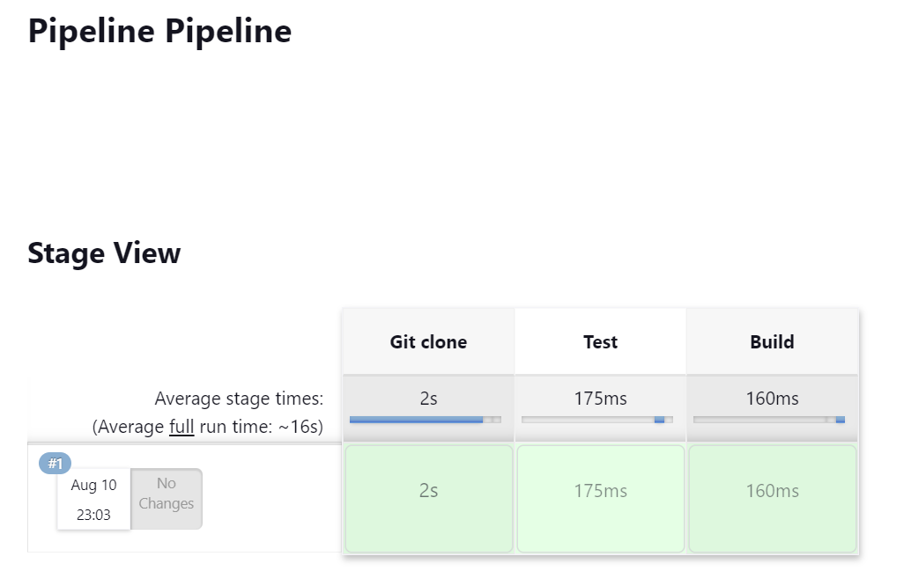

1. Maven Pipeline

* Tạo New job

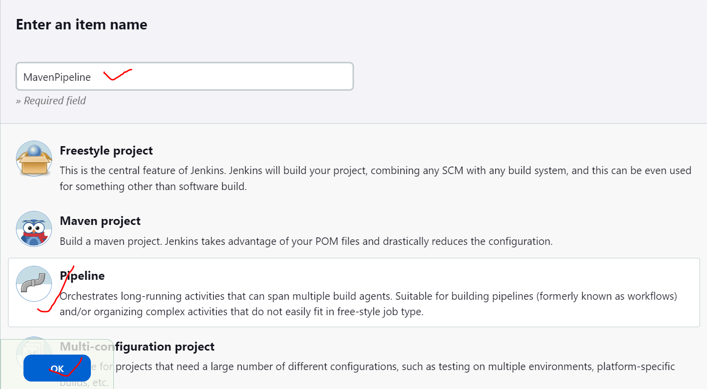

* Tạo sample code:

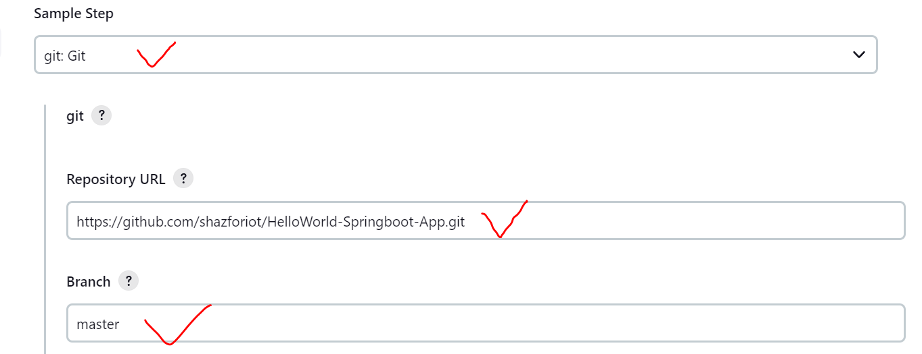

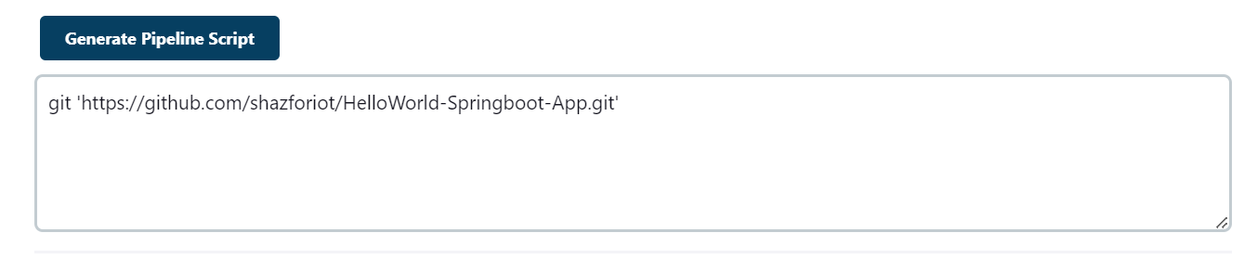

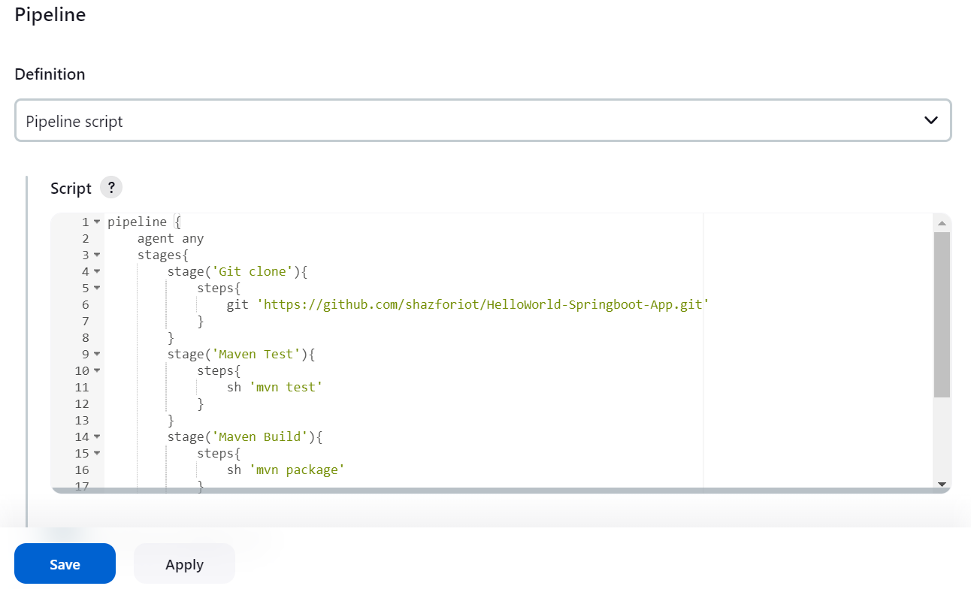

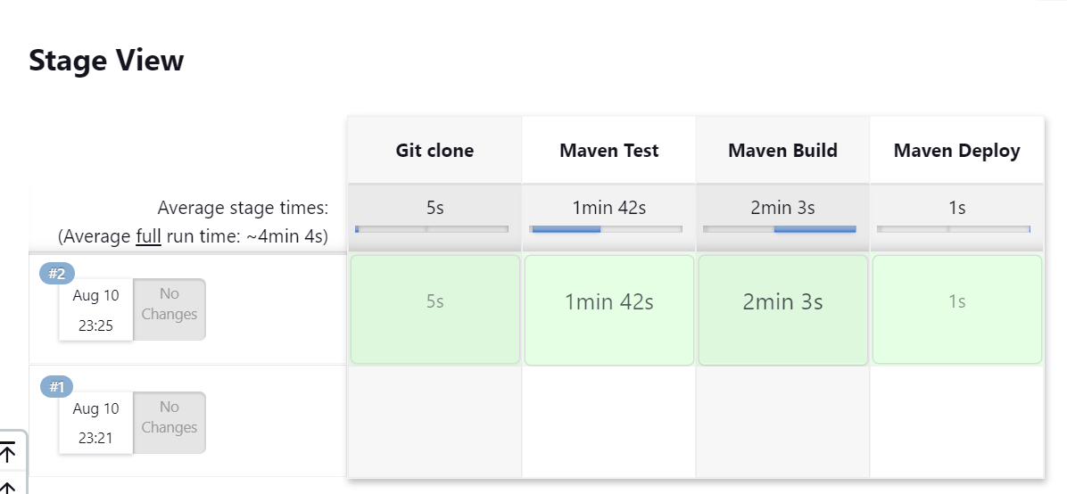

1. Jenkins Master – Slave

**Trên Jenkins Slave:**

Cài đặt Java

# yum install java-11-openjdk -y

Thêm biến môi trường PATH

# *vi /etc/profile*

|  |
| --- |
| export JAVA_HOME=/usr/lib/jvm/java-11-openjdk-11.0.19.0.7-1.el7_9.x86_64/  export PATH=$JAVA_HOME/bin:$PATH |

Tạo user

*# useradd jenkins*

*# passwd jenkins*

**Trên Jenkins Master**

Tạo SSH Key

*# su – jenkins*

*# ssh-keygen*

*# ssh-copy-id -i .ssh/id_rsa.pub Jenkins_Slave_IP*

*# ssh 192.168.1.15*

*# exit*

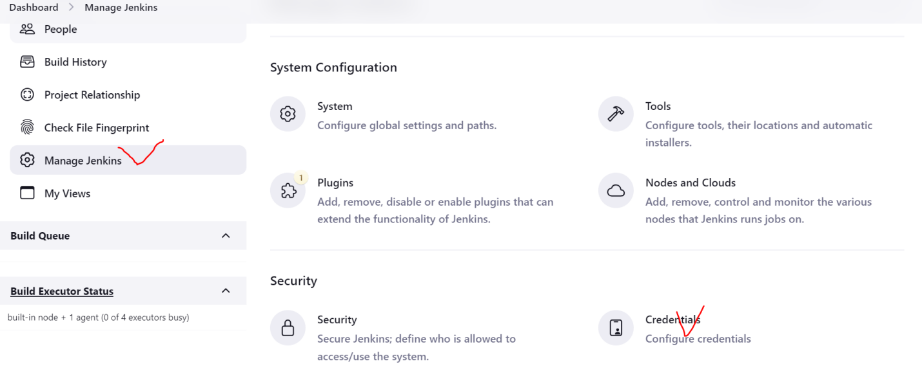

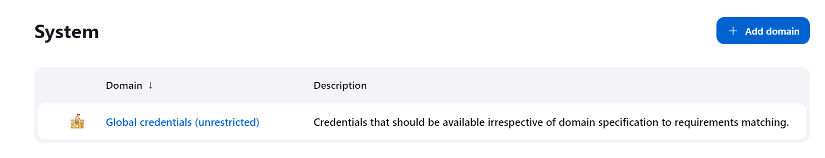

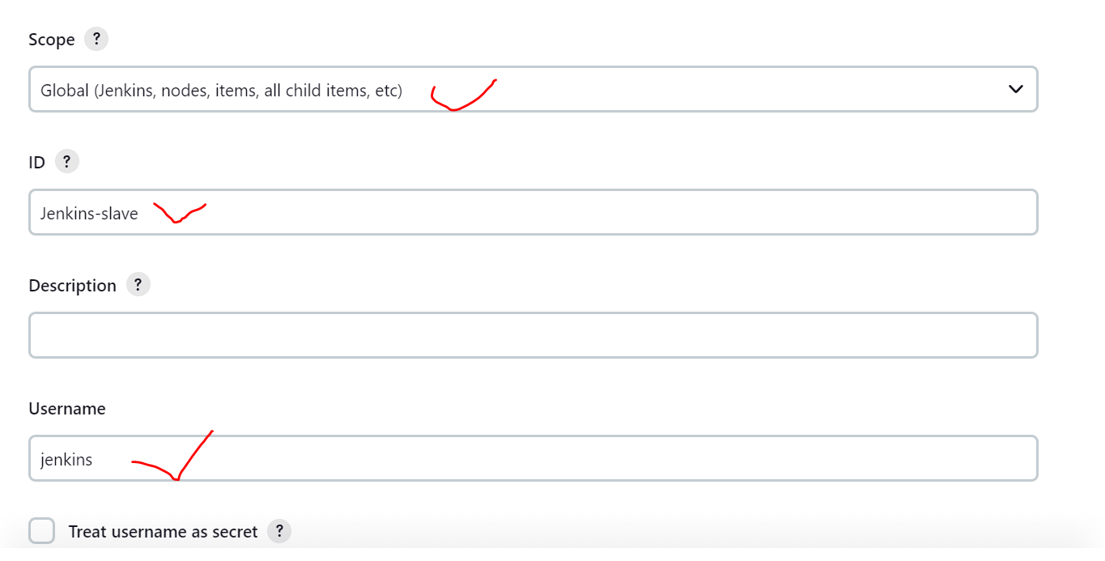

Copy Private Key rồi paste vào phần Key

# *cat .ssh/id_rsa*

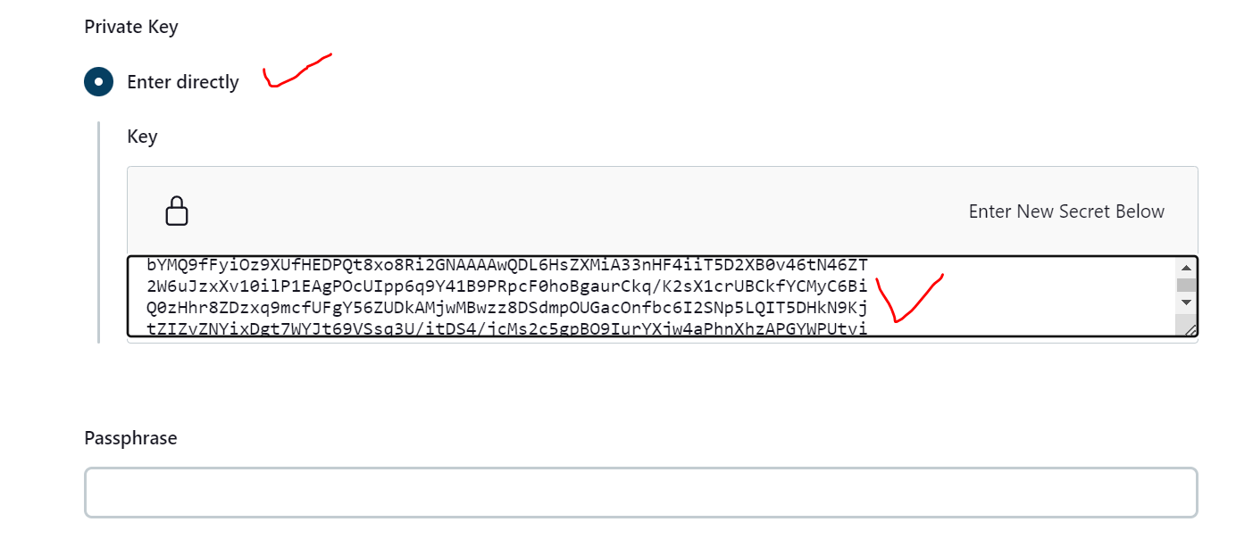

Tạo Node Slave

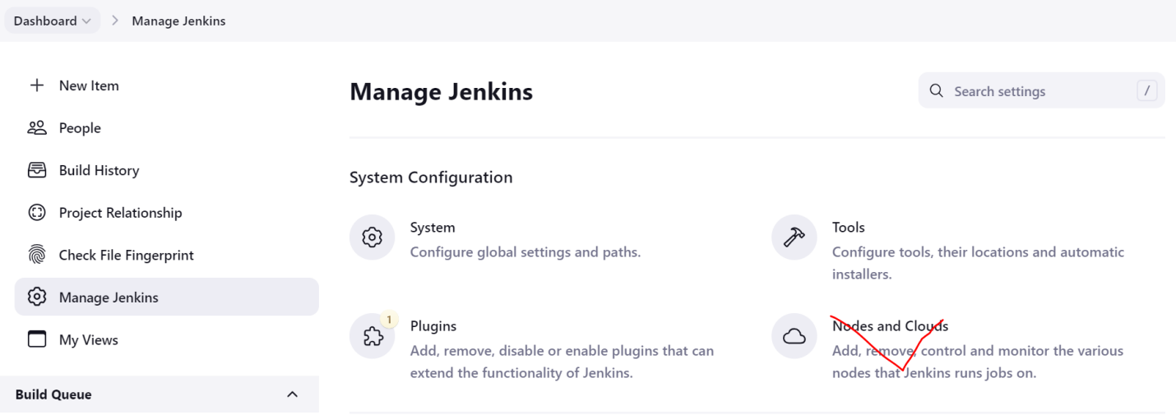

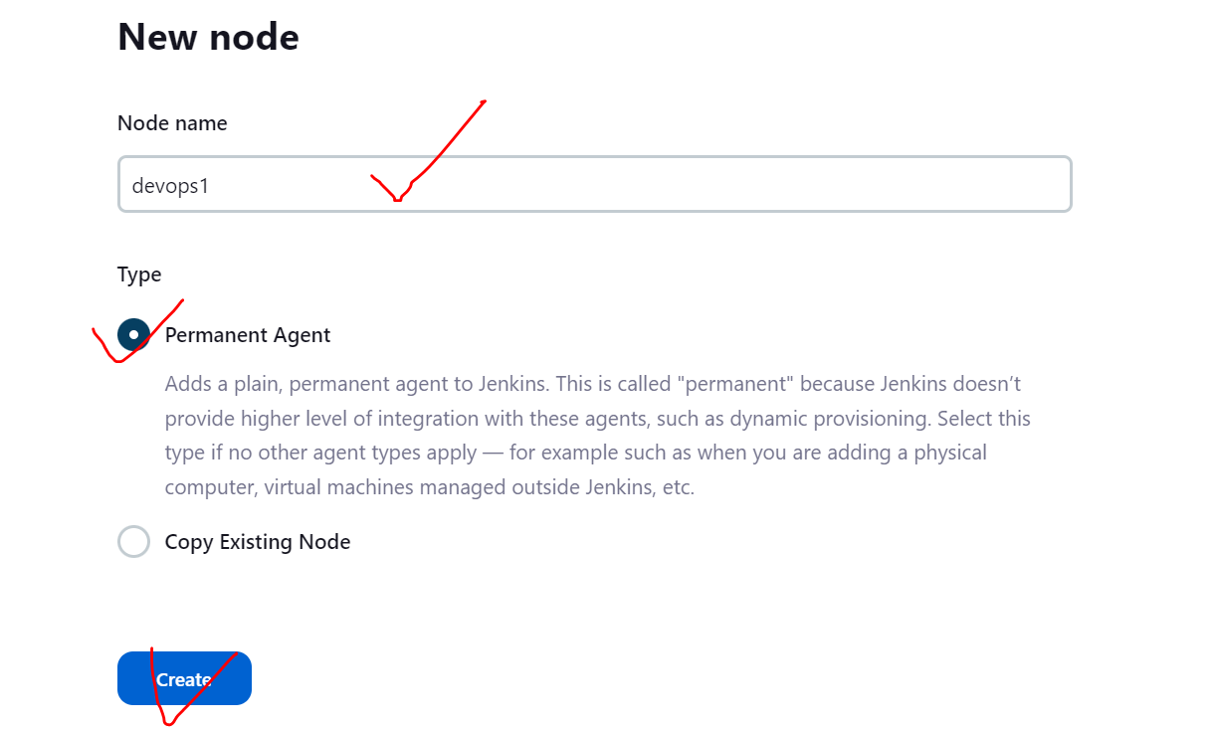

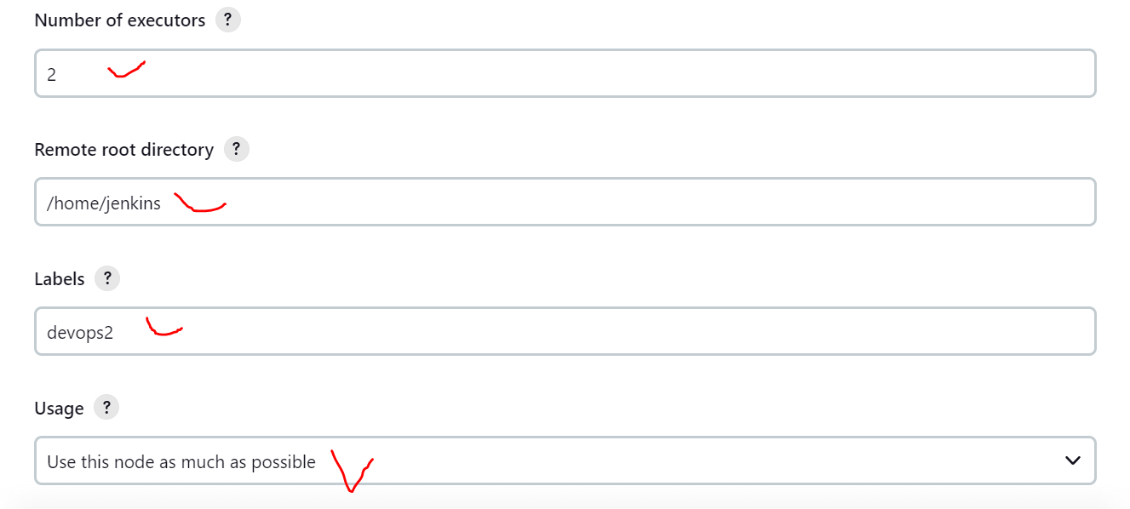

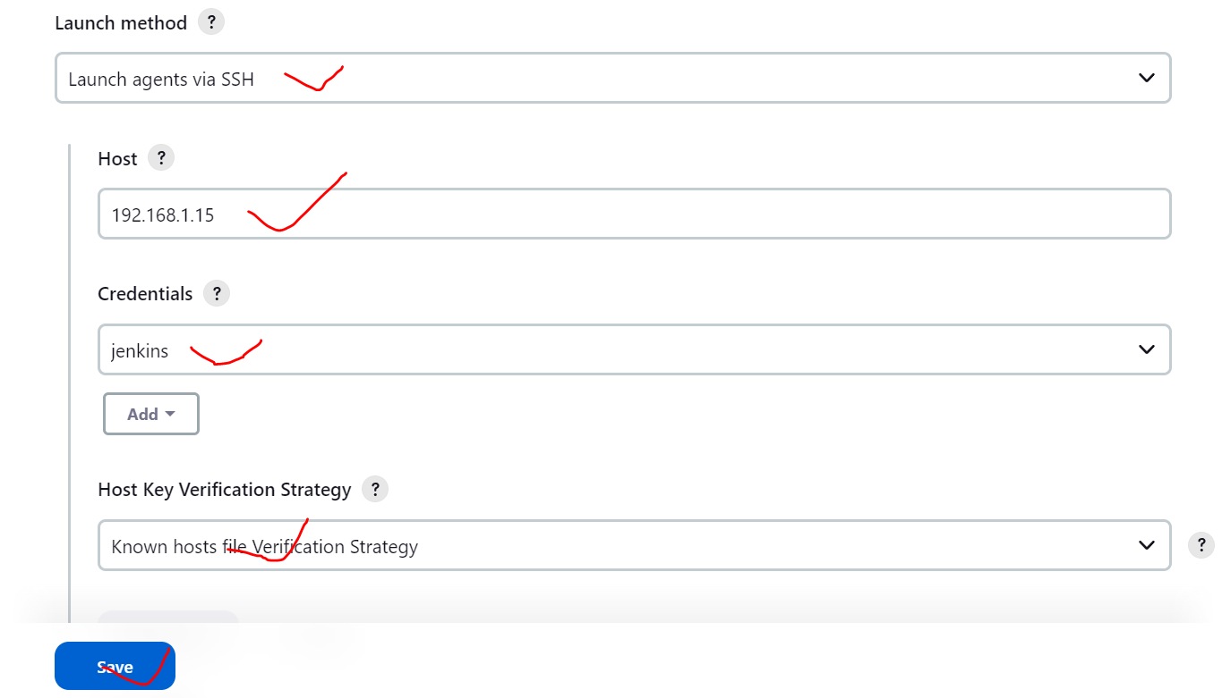

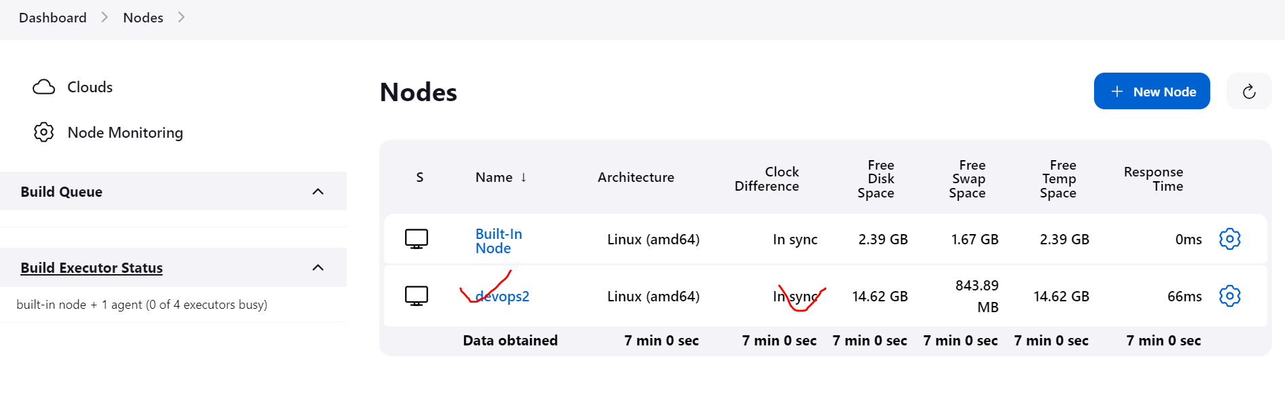

Tạo Job

